janstone@ameritech.net

IALD Presents an Award of Excellence for the Pulrose Power Station
Speirs and Major Associates Accepts Award
New York, NY, April 13, 2005 – At its 22nd Annual IALD Awards Presentation, the International Association of Lighting Designers (IALD) is pleased to present an Award of Excellence for the Pulrose Power Station, a new gas turbine facility, located on Isle of Man in the United Kingdom. The entry was judged in the site/facade category. This year, seven projects earned awards of excellence, and two are in site/façade category. Principal lighting designer on the project is Jonathan Speirs, principal of Speirs and Major Associates in Edinburgh, also in the United Kingdom. Other lighting designers credited on the project are Sandra Downie, Carrie Donahue Bremner and Iain Ruxton
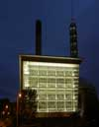 | 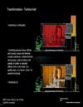 | 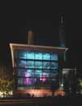 | 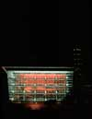 | 
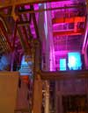 | 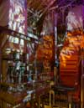 | 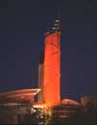 | 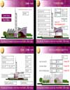 | 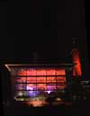
The newly built gas turbine power station is flanked by a sports center and major road, which called for lighting to would help create a more aesthetic presence. In response, exterior color-changing luminaries light the flu stack to complement the turbine hall. Internally white lights make the mesh translucent. These lights are programmed to create chases of movement up and around the stack. The completed scheme runs every evening creating a striking nighttime landmark.
“The designers have taken a utilitarian structure and transformed it,” expressed one judge. “Like an aquarium, all you want to do is stare at it!”
At this year’s 22nd annual event, the IALD awarded 23 projects that represented six of the seven categories. Seven IALD Awards of Excellence were awarded: one in both the corporate and retail/entertainment categories; two in site/façade; and three in the category of monumental structures/public spaces. The highest point earner wins the Radiance Award for Excellence in Architectural Lighting Design. In addition, fifteen projects earned IALD Awards of Merit, two in both the hospitality and corporate categories, three in the site/façade category, and four in each the retail/entertainment and monumental structures/public spaces categories. An IALD Special Citation for innovative use of materials and techniques for daylighting control was granted for an entry in the academic/institutional category.
The IALD Lighting Design Awards program, established in 1983 and co-sponsored by Professional Lighting Design magazine, honors lighting projects that display high aesthetic achievement backed by technical expertise. Entries are submitted into one of seven categories: Academic/Institutional; Corporate; Hospitality; Monumental Structures/Public Spaces; Residential; Retail/Entertainment; and Site/Façade. Additionally, projects can also be submitted for consideration in the sustainable design award category, which means the project undergoes an additional round of judging keyed solely to the fulfillment of sustainable design principles. A panel of award-winning lighting designers and architects review the projects.
This year, the IALD received 141 submissions from 14 countries. The IALD, established in 1969, is an international organization dedicated to the profession of architectural lighting design. Based in Chicago and comprised of 700 members throughout North and South America, Europe, Asia and Australia, the IALD’s role is to set the global standard for lighting design excellence.
Additional information can be downloaded from www.IALD.org.

